DTSC 671: AI Solutions in the Cloud

RAG with Amazon Bedrock Knowledge Bases

Goal
Traditional keyword-based search methods often fall short in delivering comprehensive and context-aware answers, especially when dealing with specialized knowledge contained within proprietary or dispersed documents. This lab addresses this limitation by exploring Retrieval-Augmented Generation (RAG), a powerful framework that combines the precision of information retrieval with the fluency of large language models (LLMs).

RAG systems operate by first retrieving relevant source passages from a corpus of documents (a “Knowledge Base”) in response to a user's query. These retrieved passages are then provided as context to a generative LLM, allowing the model to synthesize an accurate, grounded, and context-specific answer, rather than relying solely on its pre-trained general knowledge.

In this lab, we will simulate the foundational steps of building and utilizing a RAG system using a resource like Amazon Bedrock Knowledge Bases. The critical first step is curating a highly relevant and specialized collection of source documents to form the basis of the system's expertise. By carefully selecting documents on a specific, narrow topic, we lay the groundwork for a RAG system that can provide deep, authoritative, and well-cited responses to complex inquiries.

The primary goal of this lab is to successfully define a specialized knowledge domain and curate a set of source documents that are fit for consumption by a Retrieval-Augmented Generation (RAG) system.

Architectural Overview
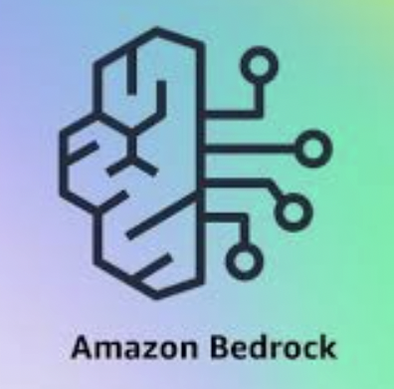


FM in Bedrock creates embeddings from documents in S3
FM in Bedrock responses to user prompts
User uploads sources to an S3 bucket

IAM role enables Bedrock to access S3 bucket

Pricing Estimate
The following estimate shows the costs you may incur on your AWS personal account.

AWS Pricing Estimate
Service | Calculation | Cost
S3 Storage | You will store at least four objects in an S3 bucket.  When I completed this assignment, I used 4 peer-reviewed academic articles (as PDFs) with a total size of 1.34 MB.  The total size is 1.34 MB = 0.00134 GB  S3 Standard pricing is roughly $0.023 per GB per month (varies slightly by region).  0.00134 GB × $0.023/GB = $0.00003082 per month | < $0.01
Bedrock | TitanEmbeddingsV2-Text-input-tokens (in US East): $0.00002 per 1K  When I completed this assignment, four peer-reviewed academic articles (as PDFs) were used with a total size of 1.34 MB, which was 80.389 1K tokens. The amount of tokens per object will vary.  Cost Calculation  - Cost: 0.00002 per 1K x 80.389 1K = 0.00161 | < $0.01
OpenSearch Serverless  OCU = OpenSearch Compute Units | IndexingOCU ($0.24 per OCU-hours)  Search OCU ($0.24 per OCU-hours)  StorageUsedInS3ByteHour ($0.024 GB-month)  When I completed this assignment, 4.8 OCU-hours were used for indexing and search, and 0 GB were used for Storage.  4.8 x $0.24 = $1.152  4.8 x $0.24 = $1.152  0 x $0.023 = $0  Total = $2.304 | $2.30
Caution: Be sure to delete the knowledge base when it’s not in use to save on unwanted charges. The OCU-hours above are charged on an hourly basis. In other words, do not create the knowledge base one day and complete the lab hours or days later! As long as the knowledge base is active, you are accruing charges to your account.

Titan Text Embeddings V2 - we will use this FM to convert our source data into embeddings (Amazon Nova Multimodal Embeddings is a more modern, more expensive option)

Claude 4.6 Sonnet - we will use this FM to make our output readable and understandable (Amazon Nova Micro is another option)

Directions
Make sure that all your services are in the same region (e.g., us-east-1)
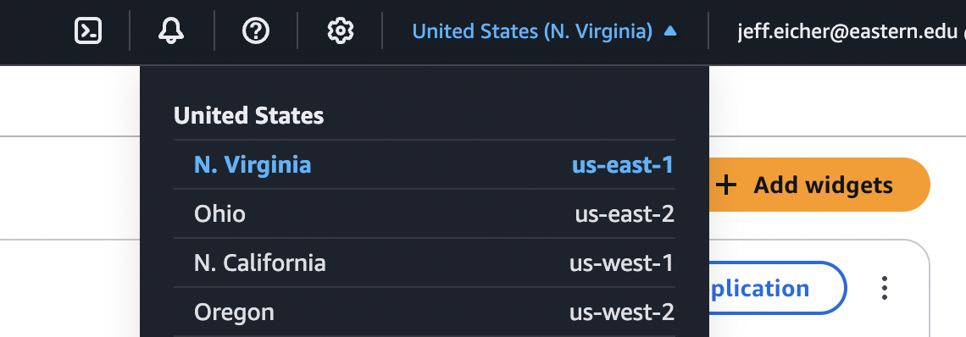

Note: I will not be providing screenshots for every step in this lab. I want you to become comfortable with navigating through the steps that Amazon provides.

STEP 1: Select source documents
- Select at least four source documents related to a topic of your choice. For example, I selected four PDFs of peer-reviewed academic articles on the topic of missing data from the EBSCO on the library website. I recommend text-heavy articles because the embedding model only processes text, so image or chart heavy PDFs may not work well.

- When you select your documents, be sure you can clearly articulate the topic, your selection of the documents, and what prompts that you could ask the RAG system. For more information, see STEP 6 below for the components of your submission on Brightspace.

- For more information about using Amazon Bedrock Knowledge Bases, see the documentation here.

STEP 2: Create an S3 bucket and upload source documents to S3
- Create an S3 bucket with a globally unique name. I recommend using “rag” in the title so you can search for and find it quickly.

- Upload all the source documents you selected in STEP 1 to your S3 bucket.

STEP 3: Create a New Bedrock Knowledge Base
- Navigate to Amazon Bedrock Knowledge Bases (You can find it on the left menu under “Build”).

- Create a new “knowledge base with vector store.”

- Rename the knowledge base (the default looks something like this: “knowledge-base-quick-start-jxga9”).
  - When configuring a data source, direct the knowledge base to the S3 bucket that you created above, where the source documents exist.
  - Create and use a service role (not an existing one)
  - Use the Amazon Bedrock default parser as the parsing strategy.
  - Use the default chunking as the chunking strategy.
  - Include key-value tagging.

- For the data storage and processing step:
  - For the embeddings model, select “Titan Text Embeddings V2” (Amazon Nova Multimodal Embeddings is a more modern, more expensive option)
  - For the vector store creation method, select “Quick create a new vector store - Recommended”
    - For the vector store type, select “Amazon OpenSearch Serverless”

- Review and create.
  - You may get an error message that “Knowledge base creation with a root user is not supported. Please sign-in with an IAM user or IAM role and try again.” If so, troubleshoot this issue.

- Wait until you get a green banner that the knowledge base is available before continuing.

STEP 4: Sync
- Return back to the Knowledge Bases main menu.

- Select the Knowledge Base that you just created (be sure it’s available first).
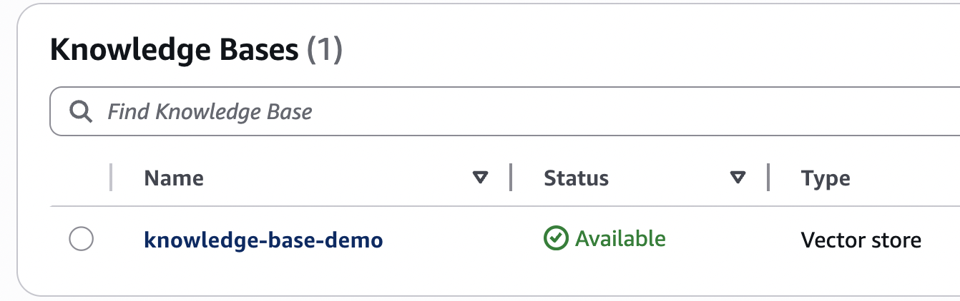

- Select the Knowledge Base and select “Sync.”

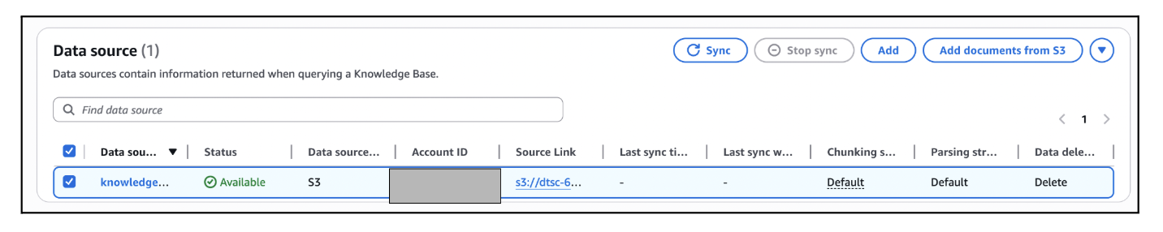

- Do not hit sync multiple times! You may get an error message.

- Wait until the sync is complete (i.e., a green banner) before moving on.

STEP 4 Tips
Some students experience the following issue:

"Data sync failed. "Knowledge base role arn:aws:iam::<accountnumber>:role/service-role/AmazonBedrockExecutionRoleForKnowledgeBase_0de4b is not able to call specified bedrock embedding model arn:aws:bedrock:us-east-1::foundation-model/amazon.titan-embed-text-v2:0: Too many requests, please wait before trying again.

1. Wait longer before retrying
- Stop all sync attempts for 2–4 hours. Then try syncing a very small test set <100 KB total.
2. Ensure previous steps align with the instructions
- Confirm model access to Titan is enabled.
- Verify the service role permissions.
3. Check your service quota. Navigate to Service Quotes → Amazon Bedrock, and search Titan Embeddings.
- If it is a quote issue, consider switching regions (e.g., us-east-1 to us-west-2), as different regions have different quotas.
- If switching regions doesn’t work, request a quota increase.

4. If all else fails, create a new account and reattempt the lab.

References:
- AWS troubleshooting guide: https://repost.aws/knowledge-center/bedrock-throttling-error
- Bedrock quotas docs: https://docs.aws.amazon.com/bedrock/latest/userguide/quotas.html

STEP 5: Test Knowledge Base
- Return back to the Knowledge Bases main menu.

- Select the Knowledge Base that you just created (be sure it’s available first).

- Select “Test Knowledge Base.” (You must sync first; see previous step).
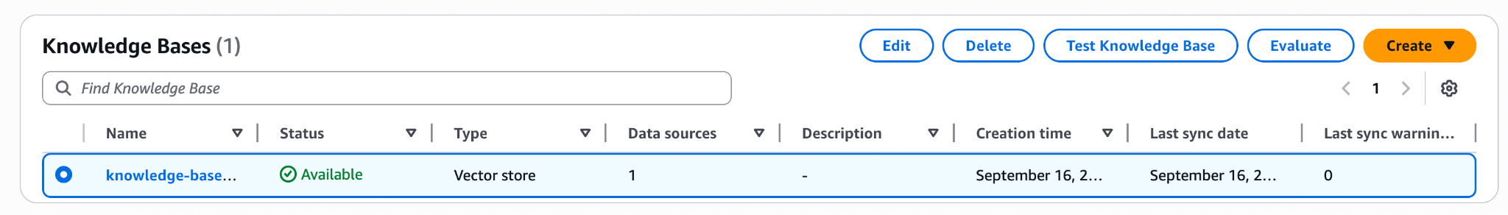

- Find Retrieval and Response Generation under Configurations, select “Retrieval and response generation: data sources and model.”
  - Under Select Model, select Anthropic, then select any available, non-legacy Claude Sonnet model as the model with “on demand” inference. (Provisioned throughput would be faster but more expensive).
    - If you’re budget conscious you can try a different model, like Amazon Nova Micro. ($0.035/million input vs. Sonnet 4.6’s $3.00/million input)
  - If you’re interested to see available Bedrock models, see here.

- Select Apply.

- You are now ready to write prompts to test your RAG system!

STEP 6: Write Prompts and Complete Submission
- Write two prompts of your RAG system that would satisfy these requirements:
  - One prompt that you ask the RAG system and another LLM (like ChatGPT and Gemini). Copy both responses, along with the original prompt (which should be exactly the same between the two LLMs).
  - Another prompt that the RAG system declines to answer (e.g., it responds, “Sorry, I am unable to assist you with this request”)

- Submit the following on the Brightspace discussion post with requested screenshots and information.
  - Be very organized so your information is easy to find and read. Use bold or headers to divide your post into these sections:
    - (10 pts) Introduction (introduce the topic that connects all the source documents)
    - (10 pts) Brief Description of each source document with citation or web address
    - (30 pts) Prompt and Responses
      - Your prompt to RAG system
      - Copy-pasted RAG response
      - Copy-pasted LLM response
    - (15 pts) Similarities (at least 2 similarities between the RAG & LLM response)
    - (15 pts) Differences (at least 3 differences between the RAG & LLM response)
    - (10 pts) Screenshot of prompt that RAG declined to answer
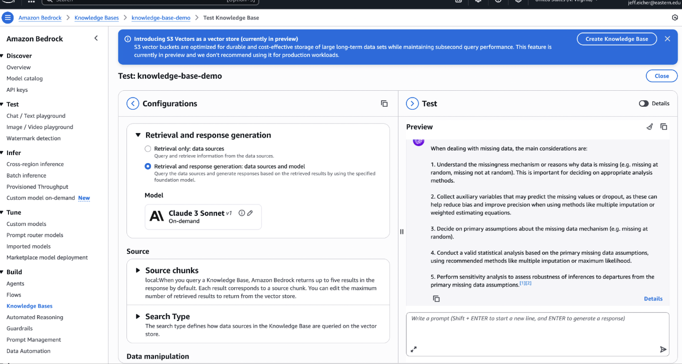
    - (10 pts) Screenshot of your RAG system test; for example:

  - Your score is based on completion, thoroughness and clarity
    - Completion: did you include everything we asked for?
    - Thoroughness: did you put thought into your responses, particularly the introduction and the similarities/differences
    - Clarity: did you use English well and communicate effectively and clearly

STEP 7: Delete Knowledge Base and OpenSearch collection!

- Be sure to delete the knowledge base when it’s not in use to save on unwanted charges. The OCU-hours ("OpenSearch Compute Units") are charged on an hourly basis.
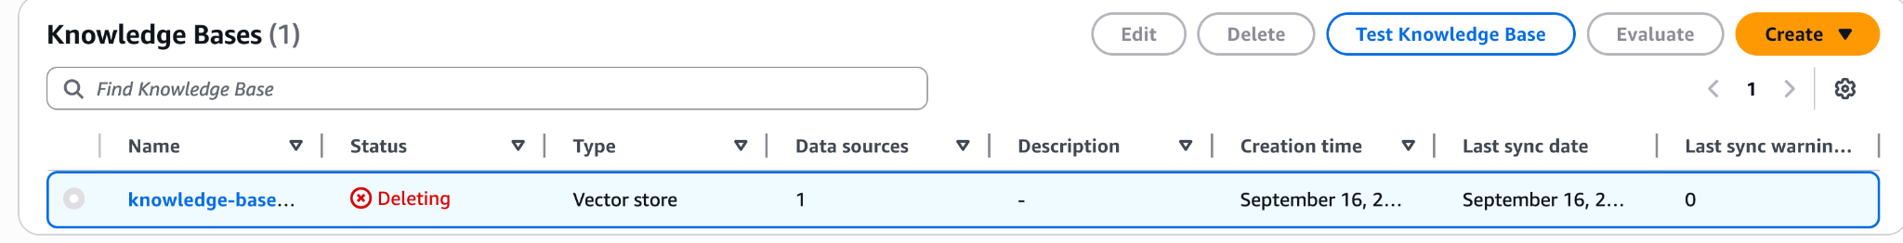
- Go to OpenSearch Service.
  - Go to the Serverless Dashboard OpenSearch.
  - Delete any active OpenSearch Collection
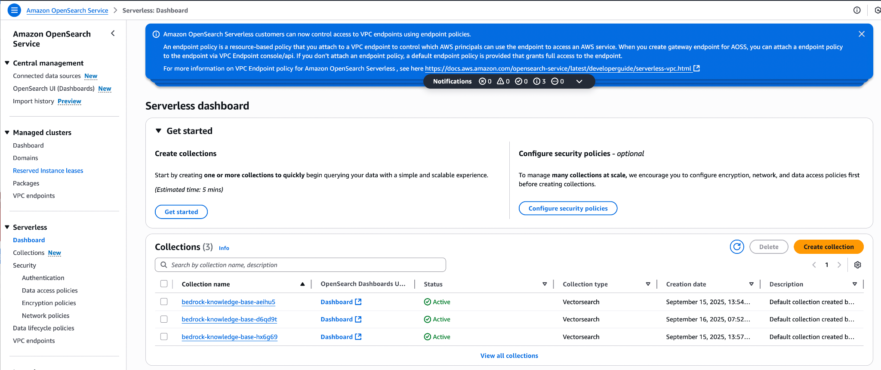

This is course material that was distributed to students enrolled in DTSC 671 at Eastern University. The materials were made exclusively available to students solely for the purpose of completing the course and are not intended for further distribution or retention beyond the course period. The materials were created by program faculty specifically for use in courses at Eastern University.

